
News release
For immediate release

The challenges and solutions to workforce shortfalls in the Eastern Townships

Sherbrooke, October 29, 2024 – For tourism enterprises, this past 2024 summer season has generally gone pretty well, and the labor situation has improved. 65% of those surveyed said that staff shortages had very little (or no) impact on their operations this season. Nonetheless, challenges persist for a significant proportion of tourism enterprises, particularly regarding recruitment difficulties, experienced by 35% of respondents.

Out of the companies that did experience workforce-related issues, 60% increased the working hours of current employees, while 50% reorganized their day-to-day operations. Several companies also had to reduce the number of days and opening hours to cope with the shortage of staff. On average, around 7% of tourism-related jobs in the region remained unfilled this summer.

The outlook for the upcoming winter season looks promising. In spite of the vagaries of the weather and uncertainties around the economy, most companies are confident that there will be a certain degree of stability. As regards the workforce, about 10% of companies operating this winter foresee any difficulties in attracting additional staff. At present, 16% of winter positions are not yet filled – a situation that will likely ease over the next few weeks, as companies ramp up their efforts to recruit more employees.

This overview of the current situation shows gradual improvement for the region compared to 2021 and 2022, and, above all, highlights how resilient and adaptable the tourism industry has shown itself to be, despite the challenge of labor shortages. That said, difficulties remain, and they call for continued efforts to promote tourism and to tackle the problems around recruitment, the need to improve the employee “experience” and to retain staff.

An outreach strategy to overcome workforce challenges
Tourism Open House
On October 4 and 5 (2024), Tourisme Cantons-de-l'Est (TCE) took part in the “Portes Ouvertes sur le tourisme” open house, an event instigated by the CQRHT (Conseil québécois des ressources humaines en tourisme). More than one hundred potential employees had the opportunity of a behind-the-scenes experience of twelve of the region’s tourism enterprises by participating in conferences, meetings, training sessions and tours.

Tourisme Cantons-de-l'Est for its part, invited around 15 students from the Techniques management in tourism program from the CEGEP (college) in Granby. The idea was for them to interact with the TCE team and to learn more about the part that an Association touristique régionale (ATR) – a Regional Tourism Association – plays within the tourism industry. The students were also able to sample a range of local products.
“We were delighted to welcome these enthusiastic students and to share with them our day-to-day role in promoting the Eastern Townships,” says Isabelle Charlebois, General Manager of Tourisme Cantons-de-l’Est. “Our tourism association has launched a number of initiatives to attract a new generation of tourism professionals, in particular by making it easier for would-be employees to have direct contact with local tourism enterprises.”

Campaign to attract tourism professionals
TCE has also launched a wide-reaching ad campaign to promote the Eastern Townships to potential workers. Rolled out over three seasons, the “Façon Cantons” segments showcase the region’s landmark attractions and key products, featuring people who already work in the region’s tourism industry.
Since it was launched, the media and content deployment has evolved to highlight some of the more unusual jobs within tourism, what training is needed and the fact that employment within the sector is year-round. The goal of the campaign is to inspire the next generation of workers to seek employment in tourism, emphasising that it is an industry that is exciting, innovative and open to everyone, no matter what their background is. The content is creative and fun with vox pop profiles – comments from the “man in the street” – to help bolster the region’s tourism enterprises and to raise awareness of the opportunities they provide to potential employees.

Initiatives to alleviate workforce challenges
TCE has undertaken a number of initiatives to help meet the challenges of recruiting personnel in the tourism industry. Potential employees can participate in the following:
- The first cohort at the Sherbrooke CEGEP’s “Accompagner son équipe de rêve” – a “dream team” training program. As part of the 8-week coaching program, participants exchange ideas about labor issues in the tourism sector.
- A community of practice facilitated by a TCE business services consultant that brings together a group of around ten companies. The purpose of this monthly meeting is to discuss day-to-day workforce issues and support each other in the challenges they face.
- Attendance and participation in trade shows around the province (in conjunction with the Vision attractivité group) and engage with the RH Lab (human resources) news page on Facebook.
- Personalized human resources coaching offered by Stéphanie Fissette, Organizational Development Consultant and Kim Lewis, Leadership Development and Change Management Consultant.

Profile of the tourism workforce
Tourism in the Eastern Townships is a major socio-economic driver. The tourism sector accounts for some 1,400 tourism-related enterprises, providing employment for over 20,000 people and it is the 5th largest employer in the region. It also has the 5th highest number of tourism-related jobs in the province of Quebec, behind the leaders, Montreal and Quebec City.
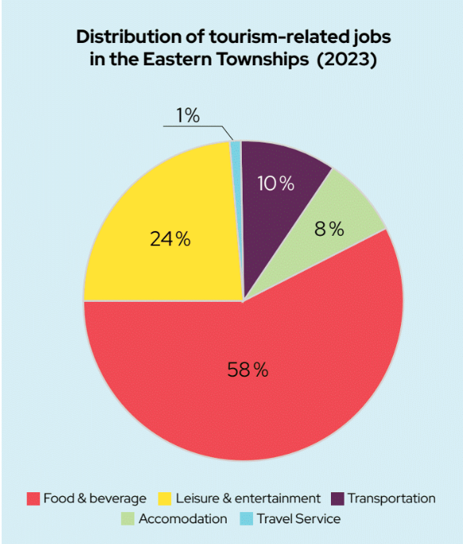
In the region, the majority of tourism businesses are small/medium-sized enterprises (SMEs). They typically employ around 10 people in high season. Over a third have fewer than 5 employees. Although they employ workers in all 9 of the region's territories, more than half are concentrated in the Sherbrooke and Haute-Yamaska MRCs.
In 2023, 56% of tourism jobs were full-time, while the remaining 44% were (flexible and diverse) part-time jobs. The Eastern Townships is unusual in that unlike some other regions of Quebec, tourism is a year-round industry, and the majority of tourism businesses operate in every season. That is particularly true of the food and beverage sector (92% yearly) and accommodation (90% yearly).
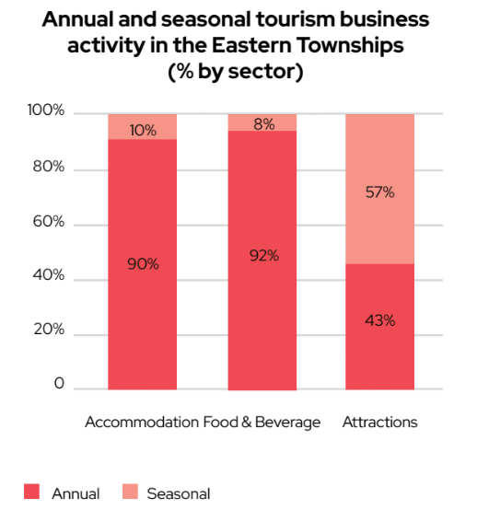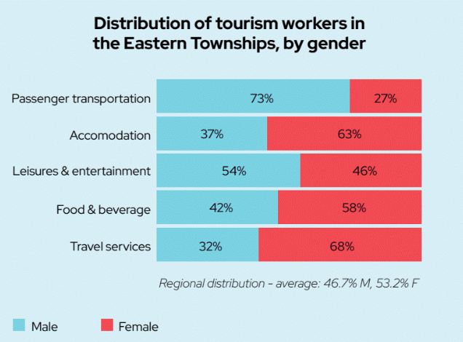
Adults aged 25 to 64 account for over 52% of tourism-related jobs in the region.Young adults (aged 15-24) make up around 43% of the workforce in the Eastern Townships’ tourism industry, higher than the Quebec average of 34.5%, and are particularly numerous in the food and beverage sector, which is similar to the trend in the province of Quebec as a whole. Those aged 65 and older represent just under 5% of the workforce and are well represented in the travel services and transportation sectors. Across the region, women account for 53.2% of employees in tourism-related sectors in the Eastern Townships, a higher proportion than the provincial average of 49.7%.
But beyond the portrait of employability specifically linked to tourism in the Eastern Townships, the tourism industry is a major lever for other employment sectors and has a significant impact on all other sectors of activity and on the region's migratory balance. In fact, it has been proven that environments with a high potential for recreation and tourism attract and retain workers. 93% of Quebecers consider that tourism contributes to the vitality and attractiveness of their region, and 82% of Quebecers who are thinking of moving or who have done so in the last three years first visited their new region for recreational purposes before settling there.

About Tourism Eastern Townships
Tourisme Cantons-de-l'Est (Tourism Eastern Townships) is one of Quebec's 21 regional tourism associations (ATR) and the official representative of Quebec's Ministry of Tourism in the region. Since 1978, TCE’s mission has been to foster the region's tourism development, promote, coordinate, support and represent the entire tourism sector, while focusing on the quality of the visitor experience. TCE brings together nearly 600 members representing more than 1,000 tourism offerings throughout the 9 regional county municipalities (MRCs) and in all sectors of the tourism industry: accommodation, restaurants, attractions, activities and events.
The Eastern Townships is the fourth most popular tourist region in Quebec, with volumes reaching 10 million visitors annually, accounting for 6.5 million overnight stays and a tourism spend of more than $900 million per year. Tourism in the region generates over 20,000 jobs, placing the Eastern Townships in 5th place for the highest number of tourism jobs among all tourism regions.
-30-

Source:
Shanny Hallé
Media Relations Coordinator | Tourism Eastern Townships
Cell : (819) 821-1220 | Email: shalle@atrce.com

