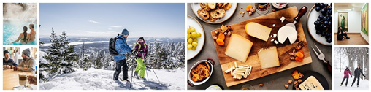



**Winter in the Eastern Townships:**

**activities, local flavours and memorable outings**

**Sherbrooke, November 14, 2024 -** This winter, the Eastern Townships will once again be a hive of activity, with endless opportunities to enjoy the great outdoors, sample local produce, relax at a spa and stay in one-of-a-kind accommodations! Throughout the region, our entrepreneurs have been busy enriching the “tourism experience”, offering new and innovative attractions and activities.

[**4**](https://www.cantonsdelest.com/article/750/a-chaque-montagne-de-ski-son-experience) **ski mountains, 4 unique experiences**

During the 2024-25 season, skiers will be able to enjoy a host of new improvements on the slopes. Our region is home to four renowned ski resorts, all within a 30-minute drive of one another – Bromont, montagne d’expériences, Owl’s Head, Mont SUTTON and Mont Orford. They have all upgraded their infrastructure to ensure even better snow conditions for skiers and snowboarders.

[**L’Est Go**](https://www.cantonsdelest.com/lestgo) **is back for a sixth year!** This interchangeable card gives unlimited access at a reduced price to the 4 Eastern Townships ski centres.

**Improvements galore at** [**Bromont, montagne d’expériences**](https://www.bromontmontagne.com/en/)

A new mobile app will now enable skiers to check snow conditions in real time. Bromont, montagne d’expériences has also added 10 high-performance fan guns to improve its snowmaking capabilities. And good news for those who love the après-ski scene! In January and February, as part of the Jeudis Shows staged by the Festival international de la chanson de Granby (an international song contest), a number of entertainers will be performing at the Bistro-bar La Débarque – a great opportunity to cheer on the local talent, as you relax after a day on the slopes!

Bromont, montagne d'expériences celebrates 60 years of skiing this winter! Stay tuned as the celebrations get underway!

[**Mont SUTTON**](https://montsutton.com/tarifs/) **offers ski touring**

A new guiding service for backcountry skiers will be offered this winter at **Mont SUTTON.** The trails run the gamut from Ouest (West) which is suitable for beginners, to the Farwest, a challenging trail designed for more experienced ski tourers – something for everyone! In addition, “splitboards” are now available for hire. Skiers will also be able to get a real-time view of conditions at altitude thanks to the addition of a new webcam at the summit.

Mont SUTTON welcomes a new mountain sculpture: The Red-tailed Hawk, created by artist Martin Hawley. This impressive 5-foot-6-inch-high work is fashioned from recycled steel, offering a play of textures and hues ranging from rusted metal to stainless steel. The stained-glass eyes add a spectacular touch to the sculpture, capturing the light that passes through them.

The après-ski season in 2024-25 on the terrace of Bar Le Tucker will be livelier than ever, with surprises and live entertainment all winter long. Stay tuned!

[**Mont-Orford**](https://www.montorford.com/fr-ca/hiver/ski-alpin/tarifs-journaliers-ski-alpin) **: Great conditions for snow aficionados!**

At **Mont Orford**, major upgrades are underway. New snow guns have been installed on the mountain and a brushcutter added to the grooming equipment, to guarantee good conditions on the trails. Other major improvements include eco-friendly modernizations to the ski chalet.

On March 29, an attempt will be made to break the record for the longest ski-shooter dating back to 1976, an experience that promises to combine fun and spectacle. A day that promises to leave a lasting impression and, let's hope, make Mont-Orford one for the record book!

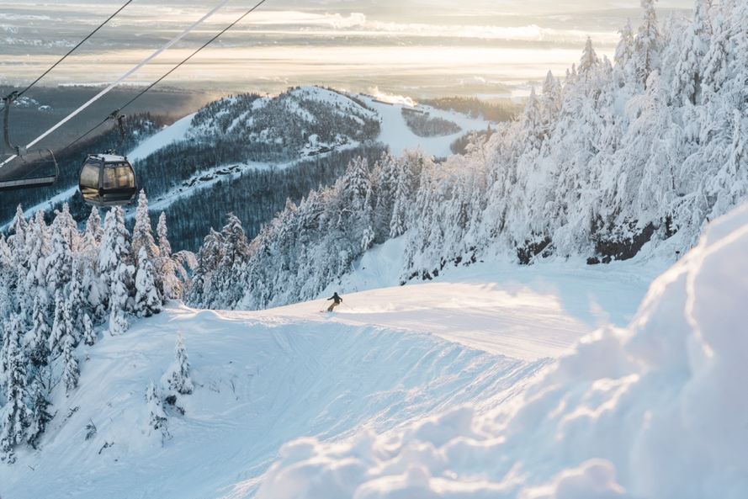

*Mont-Orford – Photo credit : Mont-Orford*

**Enhancements at** [**Owl’s Head**](https://owlshead.com/en/)

**Owl’s Head** has continued to invest in its snowmaking equipment including the addition of a new high-performance lift system. This season, there are also more trails for alpine touring - all of which add up to a better and more exciting “visitor experience”.

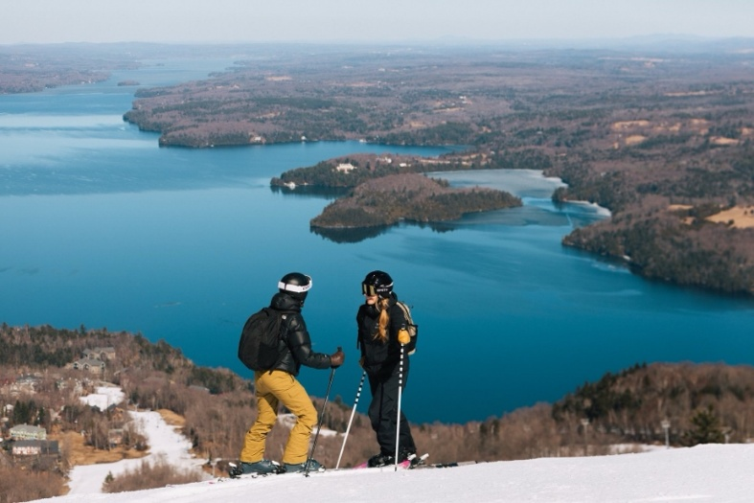

*Mont Owl’s Head- Photo credit : Jeanne Map*

**Ski touring at** [**Station Mont Ste-Cécile**](https://www.facebook.com/profile.php?id=61550796871910&refid=52&paipv=0&eav=AfZoLh-zWySmjuhgo9OXBSYscB93P_BP96CJfQsCrxc4XmLMEJj8ELXH3xQAsaCuhus&_rdr)

Lofty Mont Ste-Cécile, which towers over the land at 895 metres and with a vertical drop of 420 metres, offers a unique experience for those who love ski touring. (It also attracts mountain bikers at other times of the year.) Situated in the picturesque Megantic region, this four-season destination takes an environmental approach to the land, reflected in the rustic nature of the trails.

With the opening of two ski corridors last December and a number of mountain bike trails this past summer, the resort is predicted to become a major outdoor destination. The addition of the “Summit” sector will lengthen the network of mountain bike trails to 12 kilometres and after an effective social financing campaign, the terrain available to alpine skiers will be three times greater this winter than before. Rounding out the ski touring/mountain bike experience are the new accommodations at *Cécile Lodges,* offering direct access to the slopes.

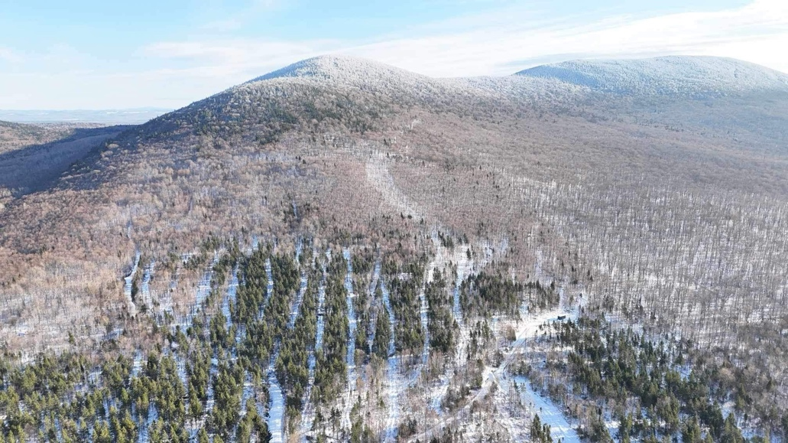

*Vue aérienne du Mont Ste-Cécile - Photo credit : Mont Ste-Cécile*

**The great outdoors**

**A one-of-a-kind activity** [**at parc national du Mont-Mégantic**](https://www.sepaq.com/pq/mme)

This winter marks the second edition of the Austrian tobogganing event at parc national du Mont-Mégantic. Whizzing down the 350-metre sledding trail is great fun for young and old alike, especially since they can get some exercise at the same time. (There’s no need to take a ski lift.) After a couple of runs on the Austrian sleds, you can hike to the summit of the mountain and its observatory from which you can enjoy spectacular views. What’s more, every Saturday evening, you can take a torchlight hike in the International Dark Sky Reserve and gaze up at the star-filled heavens – truly a one-of-a-kind activity!

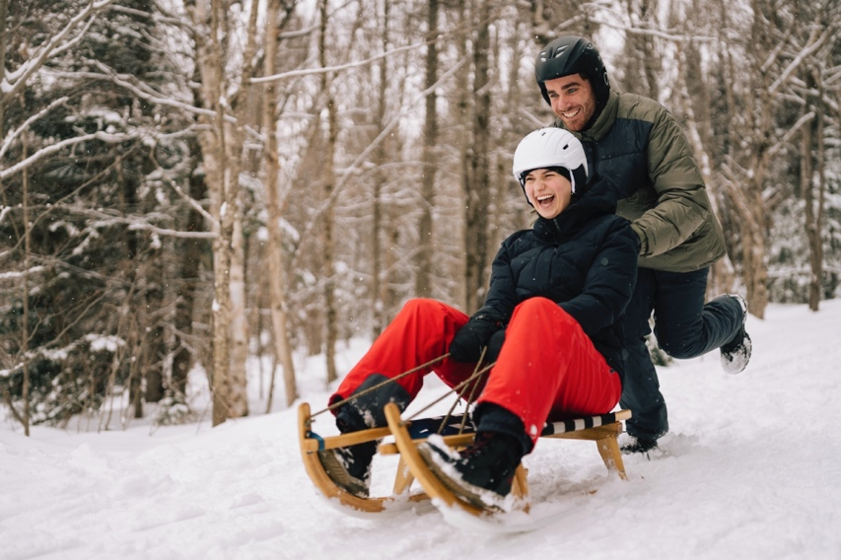

*Luge autrichienne au parc national du Mont-Mégantic- Photo credit : SEPAQ*

**Three new snowshoeing and cross-country skiing trails at** [**parc national de Frontenac**](https://www.sepaq.com/pq/fro/index.dot?language_id=2)

From December 1 to March 31 (depending on snow conditions), the parc national de Frontenac is offering an expanded winter experience with three new snowshoe trails, including a cross-country ski route. In all, four snowshoe trails will be open to enthusiasts, including three loops for modular hikes of all levels, and an intermediate-level linear trail for those looking for an extra challenge. Get ready for a total immersion in the winter nature of Parc national de Frontenac, ideal for lovers of wide-open spaces and outdoor tranquillity!

**Tailor-made tours to celebrate the 10th anniversary of** [**parc régional du Mont Ham**](https://montham.ca/)

Parc régional du Mont Ham is a destination renowned for its hiking trails and spectacular views from the summit:a 360-degree panorama of forest and agricultural landscapes. This year marks the 10th anniversary of the **Parc régional du Mont Ham** in the Des Sources region, an important milestone in its history! To mark this anniversary, the Park has developed a new promotional tool featuring a selection of **10 emblematic circuits** to highlight the Park's unique landscapes and unmissable experiences.

**A university nature reserve in the heart of Sherbrooke at** [**Parc-du-Mont-Bellevue**](https://www.parcmontbellevue.com/)

The **Réserve naturelle universitaire du Parc-du-Mont-Bellevue** in Sherbrooke was officially inaugurated on October 8, 2024. The portion of Université de Sherbrooke land included in Parc du Mont-Bellevue (PMB) is now recognized as a university nature reserve. The result of extensive work by the Université de Sherbrooke in collaboration with major partners, this reserve symbolizes a shared commitment to conservation. This designation ensures the continuation of outdoor activities in the park, as well as research and teaching activities of significant ecological value, while guaranteeing the long-term preservation of ecosystems.

**The** [**Sentier Massawippi**](https://massawippi.org/fr/articles/) **hiking trail grows even longer!**

The *Sentier Massawippi* hiking trail in Sainte-Catherine-de-Hatley has now been lengthened to 5 kilometres, offering hikers an even greater area of protected green spaces, woods and wetlands – a diverse landscape that stretches to the south of the existing trail. Home to a wealth of flora and fauna, the trail previously ended at Ethan Beach (a great spot for a picnic or a dip in Lake Massawippi) but now, about 200 metres before the final descent, hikers can walk through a forest to “Barbara’s Promenade”.

**A growing network of hiking trails at** [**Chartierville**](https://chartierville.ca/zone-tourisme/sentiers/sentiers-frontaliers/)

The [Sentiers frontaliers](https://sentiersfrontaliers.com/) organization has opened new trails in the Brise-Culotte sector of Chartierville and offering day hikes to the summits of Mont Salmon and Mont Trumbell. With 150 kilometres of trails, the network crosses the [Haut-Saint-François and Granit MRCs](https://sentiersfrontaliers.com/sentiers/longues-randonnees/) (Regional County Municipalities) giving hikers access to some of the highest peaks in southern Quebec, such as Mont Gosford (1,180 metres/3,871 feet) and Cap-Frontière (1,154 metres/3,806 feet). Along with Marble Mountain and Mount Saddle, hikers and outdoor lovers now have four challenging mountains to choose from!

**Inhale the fresh, healthy air at the** [**Réserve naturelle**](https://tourismewaterloo.qc.ca/attrait/reserve-naturelle-de-waterloo/) **in the heart of Waterloo**

Inaugurated last May, the Réserve naturelle de Waterloo is a 36-hectare protected nature reserve with 4 kilometres of rustic trails, open to the public. Tailormade for hiking, trail running (and snowshoeing in winter) the trails are flanked by totem poles created by artist Serge Poitier. This biodiverse site is open from sunrise to sunset and it offers a great opportunity to exercise in the fresh air!

*Don’t miss* the Waterloo Christmas Market! Situated at the Maison de la culture (cultural centre), the market takes place on December 14 running from 10am-5pm. Over 20 artisans and producers (mostly local) will be displaying their wares.

**Fairytale hike at the** [**Filles des bois shelter**](https://refugefillesdesbois.ca/)

From December 14, 2024 to April 6, 2025, the Filles des bois shelter in Stornoway invites visitors to enjoy a magical forest experience. Hikers can explore an enchanting winter setting where natural beauty mingles with unexpected encounters with local wildlife. Through magical landscapes, they will be guided along trails to discover the tranquility of the forest in winter.

**Birdwatching at** [**Étang Burbank**](https://www.etangburbank.com/accueil)

Étang Burbank, a popular birdwatching destination, has recently undergone extensive renovations. Landscaped by 4 kilometres of trails, a 200-metre boardwalk and an observation tower, the facilities at the Pond have all been upgraded and visitors can observe our feathered friends as they migrate south (and north in the spring). An estimated 200 species of birds make their way through this transit area and every year, in late October, this wonderful phenomenon of nature is celebrated during the **Festival des Oiseaux Migrateurs.**

**Electric vans for hire at** [**Bromont Campervan**](https://bromontcampervan.com/)

Bromont Campervan has added four new electric vans to its rental fleet. Fully insulated for the cold weather, they can be rented during the winter as well as other times of the year. They can seat up to five people (ideal for a family with three kids) and their range is 200 kilometres. The company’s rental fleet now totals 13 vans, including six eco-friendly EVs.

**Accommodations**

**Le Pavillon du Lac – Luxury accommodations at** [**Manoir Hovey**](https://manoirhovey.com/en/accommodation/lakeside-pavillon/de-luxe-du-lac/)

Manoir Hovey recently unveiled the newest addition to its luxury accommodations – Pavillon du Lac. This landmark hotel, known for a unique architectural style and its serene, natural surroundings, is nestled on the shores of Lake Massawippi. The pavilion houses 12 elegant rooms and suites on three floors (there’s also a meeting room on the second floor) and guests have exclusive access to the lake from a private jetty. Watching the sunrise from the comfort their own balcony or patio, is a breathtaking experience!

Manoir Hovey has also been honored with two “Michelin Clés” (Michelin Keys) – a new international award similar to the famed Michelin Star, but given to hotels, instead of restaurants. Michelin Keys are awarded in recognition of the unusual architecture of a building, impeccable service and a unique setting and this iconic Eastern Townships property certainly fits the bill. It embodies the very spirit of Quebec’s “art de vivre” and by joining the ranks of the world’s top 5,000 establishments, Manoir Hovey has cemented its reputation as one of the region’s leading hotels.

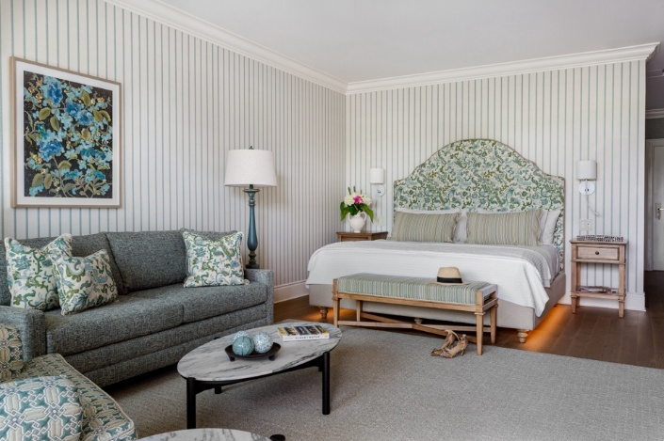

*Pavillon du Lac du Manoir Hovey – Photo credit : Manoir Hovey*

**A first anniversary for** [**Bora Boréal**](https://boraboreal.com/chalets-flottant-a-louer-estrie) **floating cottages**

To celebrate the first anniversary of its Bury site in the Eastern Townships, Bora Boral inaugurates its first art exhibition - the series of bespoke works entitled “Les reflets”, highlighting the importance of water. Josiane Lanthier's works are on display in the L'Espace-Temps pavilion and floating cottages on Lac Batley, adding an artistic and immersive dimension to this destination.

Bora Boréal offers exceptional stays in Quebec's only year-round floating cottages. Designed with the utmost respect for the environment, Bora Boréal floating chalets perfectly combine eco-responsibility, design and comfort to offer an immersive experience, as close to nature as possible. With fully-equipped kitchens, wood-burning stoves for warming up, and the option of ordering ready-to-eat meals, a stay at this unusual accommodation is the definition of perfect relaxation.

**High-end micro-chalets at** [**Parc du Mont Hatley**](https://www.monthatley.com/)

Two new high-end micro-chalets, called Lofts de Montagne, have recently been built at the top of the mountain, offering breathtaking views and direct access to biking and hiking trails. These chalets are fully equipped to accommodate up to four people, and feature optimized infrastructures for visitors. The official launch is scheduled for December 1, 2024, and reservations are already open on the website, so book now!

**Opening of new units at** [**Manoir Maplewood**](https://manoirs.ca/manoir-maplewood-old/)

In 2023, two new units were added on the first floor to accommodate larger groups at Maplewood Manor. These units are fully accessible to people with reduced mobility, ensuring full inclusion for all visitors. Maplewood Manor combines comfort and refinement in an intimate, hushed atmosphere with some fifteen rooms and suites, each with private bathroom, spacious kitchen, numerous lounges and relaxation areas, outdoor amenities including: heated pool, spa and sauna, fire pit, large terrace with BBQ, as well as a pétanque court.

**Enjoy a nature getaway with a special offer for those aged 50 and over!**

[**LAÖ CABINES**](https://www.laocabines.ca/cabines) is now offering an exclusive 20% discount for visitors aged 50 and over on weekday stays. (promo code: 50ans20%) Located in the heart of the forest, this unusual accommodation in Racine offers an immersion in nature, combining minimalism and comfort. Visitors can take advantage of hiking trails, spas and saunas right on site to explore the Val St-François. Perched on stilts, the contemporary, glass-fronted cabins offer breathtaking views of Mount Orford or Lac sauvage à Paul. Single-night bookings are also available from Sunday to Thursday.

[**Hébergement aux Cinq Sens**](https://www.auxcinqsens.ca/activites.html) **celebrates its 15th anniversary**

Hébergement aux Cinq Sens is celebrating its 15th anniversary.Since its opening in May 2009 in Piopolis, the company has charmed nature and wellness enthusiasts with its unique accommodations and sensory experiences in the heart of nature, in keeping with aboriginal values. Partnering with other local tourism entities, guests are eligible for discounts at venues like Estello Suites and Spa; Mont Megantic National Park (star-gazing); Baie-des-Sables Resort (winter sports) and *Mohigan Aventure* (wilderness activities). The company was recognized in the Responsible and Sustainable Tourism category at the Prix excellence Tourisme 2024 awards.

**Discover** [**Domaine Jolivent'**](https://jolivent.ca/)**s ski and long-stay offers**

Domaine Jolivent has two exceptional offers to help you make the most of the region. The [Ski Package,](http://softbooker.reservit.com/reservit/reserhotel.php?action=resa&id=58&hotelid=445508&rateid=3518348&ratecustid=58&nbnights=2) available from December 1, 2024 to March 31, 2025, includes accommodation in an enchanting setting, ideal for winter sports enthusiasts. The [Long Stay Offer](http://softbooker.reservit.com/reservit/reserhotel.php?action=resa&id=58&hotelid=445508&rateid=3782897&ratecustid=58&nbnights=3), valid from November 1, 2024 to May 31, 2025, allows visitors to extend their stay and explore the region at their own pace. Whether you're looking to make the most of winter or discover the tranquility of spring, this offer provides the perfect setting to recharge your batteries and appreciate the beauty of the region.

**Gourmet food in cozy surroundings at** [**Cecil House**](https://www.lacecilhouse.com/)

La Cecil House is a historic hostelry in Stanbridge East – a cozy, comfortable spot to recharge your batteries on a getaway to the Eastern Townships. Together with its next-door neighbour and partner, [l'Espace Old Mill](https://www.espaceoldmill.com/), it now offers packages that include a 4-course gourmet meal, as well as overnight accommodation.

**What’s new at** [**Motel Le Château**](https://www.hotelmotellechateau.com/)

Motel le Château is a quiet, welcoming hostelry with views of the water, situated only two minutes from downtown Lac Mégantic, the arena and the beach. Local artisans now sell their handicrafts onsite and there is a brand-new pub situated within the building.

[**La Capitainerie**](https://www.facebook.com/profile.php?id=61557835509972) **: A new hostelry on the shores of Lac Megantic**

From January 2025, immerse yourself in a unique experience on the shores of Lake Megantic at La Capitainerie, a lodging where refinement meets tranquility. Offering breathtaking views of the lake and Parc des Vétérans, this place perfectly blends nature and modernity. Enjoy breathtaking scenery from your private balcony, whether for an early morning coffee or a spectacular sunset.

**Spas and relaxation**

**New massage yurts at** [**Spa Bolton**](https://www.spabolton.com/massages/)

From mid-November 2024, Spa Bolton will be offering its relaxation experience with six new massage yurts, set in the heart of nature. Nestled at the foot of the Missisquoi River waterfalls, these yurts offer a unique environment where visitors can let themselves be enveloped by the benefits of massage. This enchanting setting is an invitation to a total escape, lulled by the sound of water and the scent of woodland, for a moment of serenity in harmony with nature.

**A renewed experience for** [**Solstice Sauna**](https://solsticesauna.com/)

The Solstice Sauna experience will now be back in a new location as of November 18! The sauna unit is designed to be a place in harmony with nature that encourages contemplation, relaxation, connection with the land and socialization among participants. The [**Station du Chêne Rouge**](https://stationchenerouge.com/) in Hatley Township will be the setting for this experience, with a cold-water swim in a naturalized pond. Located just 15 minutes from Sherbrooke, Station du Chêne Rouge is an ideal vacation destination for modern travelers.

[**BALNEA spa**](https://www.balnea.ca/experience-thermale-2/) **takes the relaxation experience to a whole new level!**

Balnea Spa is reinventing itself! Thanks to recent renovations that include an infinity pool (with breathtaking lake views) and a beach-themed pavilion (complete with real sand!) spa-goers will enjoy the relaxation experience on an entirely new level. As well as these additions to the infrastructure, Chef Maxime Delmon will now be in residence at the LUMAMI Restaurant. He creates healthy, colorful dishes using ingredients from the spa’s own gardens and local producers, based on what’s in season.

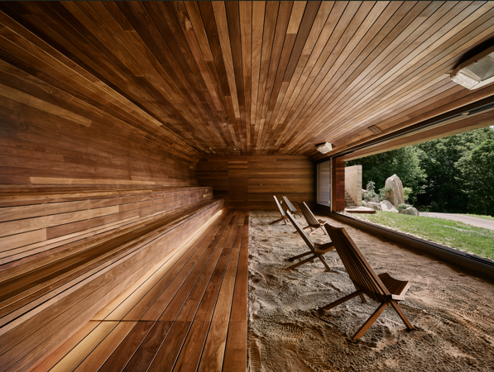

*Photo credit : BALNEA spa – Maxime Brouillet*

[**Spa Nordic Station**](https://spanordicstation.com/) **celebrates 20 years of wellness**

Surrounded by nature on the banks of the Castle River, only five minutes from downtown Magog, Spa Nordic Station offers a wide range of indoor and outdoor facilities including a Russian “banya” (hot and cold baths), California baths or Finnish saunas. The wellness centre has been celebrating its 20th anniversary since July (until the end of 2024) with special rates for spa-goers.

**All-round relaxation at** [**Estello Suites & Spa**](https://www.estello.ca/)

Situated on the shores of scenic Lac Mégantic, Estello Suites & Spa is an ideal venue for a romantic getaway and it offers endless opportunities to enjoy outdoor activities – cross-country skiing, snowshoeing and snowmobiling (to name a few). The resort has a full-service spa with three tubs, a cold plunge pool, a hammam (steam room), a heated dome, a relaxation room, massage chairs and red-light therapy sessions – a range of wellness facilities offering an all-round relaxation experience!

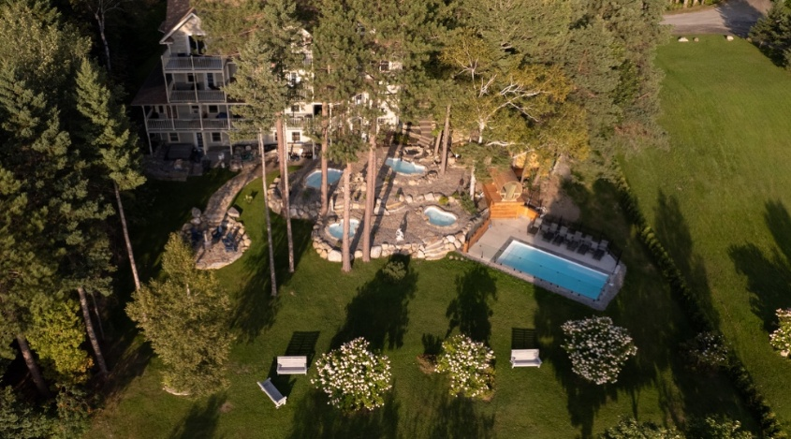

*Estello Suites & spa – Photo credit : Estello Suites & Spa*

**New this winter at the** [**Strøm Spa**](https://www.stromspa.com/) **in Sherbrooke**

Just minutes from Sherbrooke’s Parc Jacques-Cartier, in the natural setting of Lac des Nations, the Strøm Spa is a haven of relaxation and healthy food. Nord, its restaurant, was previously open only to spa-goers, but now the general public can enjoy the gourmet fare. Another new offering this winter is a guided meditation workshop. It takes place in a dry sauna and combines cardiac coherence, mindfulness and aromatherapy – a deeply relaxing therapy for body and mind.

**Wellness retreats at** [**Spa Eastman**](https://spa-eastman.com/)

Known for its unique approach to wellness, Spa Eastman is offering daylong retreats, designed to revitalize the body and calm the mind. This winter, more than 50 retreats will be offered by this internationally renowned wellness centre – each one led by experts with diverse approaches to health. Spa Eastman has also become the first certified *Shinrin Yoku* (forest bathing)wellness centre in Canada, adding to the extraordinary choice of therapies now available in the Eastern Townships, boosting its reputation as a leading destination for spa-goers.

In January 2025, they will launch the first English-language edition of their popular [*Aspiring Chef*](https://www.spa-eastman.com/en/stays/retreats/aspiring-chef-in-tonique-cuisine/) culinary retreat. This immersive retreat will allow participants to explore the art of tonic cooking, guided by experts in food and wellness.

In addition, a new evening formula will be introduced, offering guests two inspiring lectures, followed by a spa experience and gourmet dinner. To celebrate the holiday season, Spa Eastman has also prepared a special program full of surprises and treats.

**Gourmet**

**Five Diamonds for** [**Le Hatley**](https://manoirhovey.com/en/restauration/restaurant-le-hatley/)**, Manoir Hovey’s restaurant**

Manoir Hovey’s Le Hatley restaurant has recently earned one of the highest culinary ratings in North America – the acclaimed Five Diamonds CAA-AAA Award. The hotel, which is in North Hatley in the Eastern Townships, showcases Quebec products on its menus, inviting diners to enjoy a gastronomic “journey”, rich in colorful, flavorful dishes. Manoir Hovey belongs to the prestigious Relais & Châteaux association and its chef, Alexandre Vachon, now ranks among one of a very select group of cuisiniers.

**Exclusive events aboard** [**Grand Cru**](https://escapadesmemphremagog.com/explorez-le-grand-cru/le-bateau/)

This winter, the Grand Cru can be booked for dockside events (October to May). The sailing season is during the summer but the boat itself is an elegant, unique venue for a variety of gatherings - product launches, business meetings, networking and the like. Participants can enjoy the spectacular views of Lake Memphremagog and its mountain scenery. Moreover, holding something aboard a vessel certainly makes it stand out from the crowd!

PAL+ (which operates the boat) has also launched a **mobile app** to make it easy for clients to access information about its eight tourist locations across the Eastern Townships. The app’s features include online reservations, a GPS map, live chat etc.

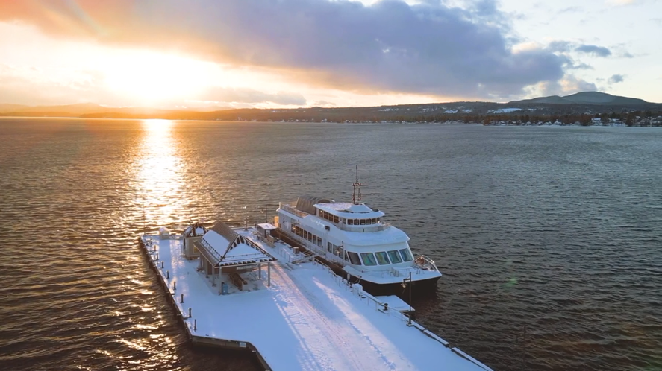

*Le Grand Cru- Photo credit : Escapades Memphrémagog*

**A country-style winter table at** [**Espace Old Mill**](https://www.espaceoldmill.com/)

L'Espace Old Mill is primarily a farm where even in winter, fresh vegetables (grown in a greenhouse) are available. Operated by passionate food lovers, this farm/restaurant, which was named as one of the 10 best new dining establishments in Canada by  [EnRoute/Air Canada](https://enroute.aircanada.com/fr/restaurants/meilleurs-nouveaux-restos-canadiens-2023-espace-old-mill-stanbridge-quebec/), offers visitors a warm welcome with menus featuring tasty local dishes.

This winter, L'Espace Old Mill offers an authentic gourmet experience for Christmas, with a festive 4- or 7-course menu made entirely from local, seasonal produce. Local agriculture is celebrated in every dish, offering a unique culinary escapade. What's more, throughout the season, guests of the restaurant and inn can enjoy a free tour of the farm and greenhouse every Saturday, adding an immersive dimension to this unforgettable experience.

[**« Décembre au vignoble »**](https://www.laroutedesvins.ca/decembre/) **along the Brome-Missisquoi Wine Route**

The Wine Route is inviting wine lovers to sample some of the prime products produced in the region of Brome-Missisquoi. The “December at the Vineyard” event celebrates the holiday season with wonderful wines that will tempt your taste buds and get you into the holiday spirit! (December 7 and 14.)

Bundled up in your winter clothes, meandering through the backroads of our region on a cool, crisp day, there will be nothing more welcoming than a stopover at one of the wineries! You’ll find all kinds of diversions to warm you up – guided tours, gourmet treats, tastings, cocktails, fire pits, craft sales, gift baskets… The list goes on. The Eastern Townships region is the cradle of the wine industry in Quebec. It boasts the first designated wine route in the province, encompassing over 20 vineyards that produce 60% of all wines in Quebec.

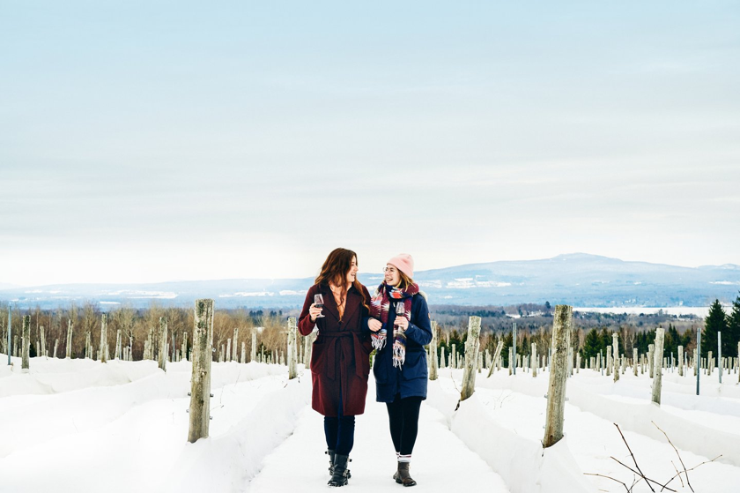

*Vignoble Léon Courville en hiver – Photo credit : Daphné Caron*

**A new Quebec cheese to try at** [**Fromagerie Nouvelle-France**](https://fromagerienouvellefrance.com/)

Fromagerie Nouvelle France in Racine unveils its latest creation: a pasteurized cow's milk cheese with a soft, washed rind, named HOUDE le patriarche. The cheese pays tribute to the descendants of Louis Houde, a common ancestor of many Quebecers. HOUDE le patriarche adds to a range of cheeses deeply rooted in Marie-Chantal's family heritage, alongside the famous Zacharie Cloutier, which honours her maternal line, and La Madelaine. Since it was founded in 2010, Fromagerie Nouvelle France has established itself on the Quebec and international cheese scene, racking up more than 60 awards in Quebec, Canada, the United States and elsewhere in the world.

**La** [**Grande Foire des Saveurs**](https://www.zeffy.com/fr-CA/ticketing/7d881b96-7d7b-4d3d-a410-06894db7f9e5)**: a feast of gourmet discoveries**

On February 1, 2025, from 10 a.m. to 4 p.m., the Grande Foire des Saveurs, presented by the Créateurs de Saveurs des Cantons-de-l'Est, sets up shop at the Centre de Foires de Sherbrooke for a day dedicated to the pleasures of the terroir. With nearly 80 gourmet kiosks, this not-to-be-missed event immerses visitors in the wealth of local produce.

With family or friends, discover the authentic flavours of the region as you explore the creations of our passionate artisans. This unique gathering is the ideal opportunity to meet producers, learn more about their know-how, and sample a variety of products that are the pride of the Eastern Townships.

**Dynamic programming at** [**Café Fabulé**](https://cafefabule.ca/)

This winter, Café Fabulé is offering a dynamic program, with a Christmas Market on November 23 and 24, writing and creative arts workshops, and 5 à 7 Thursdays with a bistro menu. The Fabul'Art Wall will feature the works of Marie-Ève Plante from November 5 to December 28, 2024, followed by those of Raphaël Landry Versaille from December 31 to March 1, 2025. Come and share enriching moments at the café !

**Combine brunch and racing at** [**Siboire Jacques-Cartier**](http://www.siboire.ca/fr/succursales/jacques-cartier/)

Located on the shores of Lac-des-Nations, the Siboire Jacques-Cartier offers a menu ideal for lunches and dinners in good company over beers made on site. On January 18, the Brunch Run event will celebrate the New Year! Whether you're new to running or a seasoned enthusiast, you'll enjoy a course accessible to all, with 5 and 10 km options, in collaboration with Le Coureur boutique, Courir boutique and Café Hubert Saint-Jean. Afterwards, a convivial brunch awaits you at the Siboire Jacques-Cartier, accompanied by Hubert Saint-Jean coffees. Reserve your place now!

**Breakfast at** [**L’Érablière du Village**](https://erabliereduvillage.ca/pages/menu-sur-place)

L'Érablière du Village in Compton offers a number of seasonal menus at different times of the year – a beer garden menu, a sugaring-off menu and now, a holiday special, namely breakfast. The dining room opens at 8am each morning and the breakfast menu runs until noon. On Saturdays and Sundays, the beer garden menu is served after midday (until 8pm). There are also walking trails throughout the maple grove (open year-round) where you can work off all those calories.

[**Le Roux**](https://www.monsieurleroux.com/) **celebrates its first year!**

Le Roux in Bromont, a restaurant, bar and boutique, recently celebrated its first year in business by refreshing its menu. Classic and customer favorites have remained but are being augmented by seasonal dishes. Discounts and specials will be on offer on Tuesdays and Wednesdays and a new tradition – Karaoke evenings – will be making its debut! Get ready to tune up your voice…

[**Cidrerie Compton**](https://cidreriecompton.com/) **– from Compton, all the way to Japan!**

Cider lovers in Japan will now be able to enjoy the products made by **Cidrerie Compton**. The cider maker, which makes certified organic beverages known for their high quality and unique flavours, is branching out, exporting their passion and expertise to other countries. Haskap berries, which are rich in antioxidants, are among the ingredients of these distinctive ciders, already very popular in the Eastern Townships.

**Family activities and cultural attractions**

**Momenti: plunge into the heart of the** [**Marais de la Rivière-aux-Cerises**](https://maraisauxcerises.com/?srsltid=AfmBOorL2vVKXOE-rbU5byGLOx1Nl6WDUq1O9_OoY7st7GwuWKczDFx9)

Discover Momenti, the new immersive permanent exhibition at the Marais de la Rivière-aux-Cerises. The fruit of two years of passionate work, this installation offers a unique experience, inviting visitors to explore the biodiversity of the Marais through an artistic perspective. You'll be able to admire some fifty animal and plant species in the rhythm of the seasons, in a room transformed into a multimedia environment where every image and every moment inspires. The production of this visual and poetic experience has been entrusted to Carrier Communication & Design.

From Saturday November 30, come and discover this exhibition free of charge during opening hours at the Centre d'interprétation du Marais. Immerse yourself in this captivating space where nature and technology meet to celebrate the beauty of life and raise awareness of the region's ecological wealth.

**A new podcast for the** [**Town of Brome Lake**](https://tourismelacbrome.com/en/)

The *Histoires du Lac* (*History of the Lake*) podcast offers visitors a unique perspective on the rich, fascinating history of the Town of Brome Lake. Louise Penny and Raymond Cloutier recorded the narratives for the podcast, relating tales of people and places from the past that have shaped the character of the community. All four episodes are now available online.

**Follow the hiking trail with the** [**Parcours du Circuit de l’Abbaye**](https://baladodecouverte.com/circuits/1294/circuit-de-labbaye--cantons-de-lest) **app**

Hikers have a useful new tool - the BaladoDécouverte cellphone app - that provides in-depth information about the 149-km route covered by the *Parcours du Circuit de l'Abbaye*. The app operates a GPS-enabled interactive map of the Saint-Benoît-du-Lac hiking circuit, as well as 12 audio clips describing various sites along the way.

**New space exhibition at the** [**Musée de la nature et des sciences de Sherbrooke**](https://mns2.ca/)

The exhibition*Objectif Terre : Comprendre notre planète depuis l'espace*  explores how observing Earth from outer space can influence life on our planet, helping to nurture, protect and monitor any significant changes around the world. Thanks to the high-quality photographs taken by astronauts, visitors can learn about advanced Canadian space technology through interactive exhibits – an educational experience for young and old!

[**Prison Winter**](https://mhist.org/?gad_source=1&gclid=CjwKCAiAxKy5BhBbEiwAYiW--27aknUmwXDYwHyzFajIpVmPUyPM_u7k1vPTX0AzAvF2q74Z-JTtPBoCHi0QAvD_BwE) **finally classified as a heritage building**

On November 6, 2024, the Société de sauvegarde de la vieille prison de Sherbrooke and the Mhist-Musée d'histoire de Sherbrooke celebrated the recognition of the old Sherbrooke prison, or Winter prison, as a classified heritage building by the Ministère de la Culture et des Communications du Québec. This recognition, awaited since April 1990, aims to preserve the integrity of the building and enhance its historical significance. The prison, which operated from 1869 to 1990, is now run by volunteers and could become a cultural and museum site thanks to this new designation.

**New exhibitions at the** [**Musée des beaux-arts de Sherbrooke**](https://mbas.qc.ca/en-cours/)

The Fine Arts Museum in Sherbrooke will be hosting several new activities and exhibitions in the coming months:

* *Balade en forêt* - from September 26 to January 5, 2025. This exhibition, drawn from the MBAS collection, showcases the work of guest artists Alexandra Bachand and Thomas Corriveau. Themed around a forest walk, it invites visitors to identify the plants they encounter along the way.
* *Biennale des artistes des Cantons-de-l’Est : L’écologie du paysage* – from September 26, 2024 to January 5, 2025. An exhibition focusing on the role of art (and artists) in documenting and interpreting the region’s landscapes.
* *Parcours Photo Sherbrooke* at Lac des Nations in Sherbrooke (free). 2024 is the 10th anniversary of this outdoor art exhibition. It features the work of three local professional photographers who through their lenses, have captured the very essence of downtown Sherbrooke from every aspect – physical, creative, social and architectural.

**A slew of new attractions at** [**Musée Beaulne**](https://www.museebeaulne.qc.ca/)**!**

Beginning November 17, the Museum will be showcasing the winter exhibitions. Denis Giroux's *Grand-Nord*, *Grand-Sud*, *photos d'ailleurs* will unveil striking photographs of the Arctic and Antarctic, while Julie Vanasse's *Cantons intemporels* will reveal the hidden treasures of our magnificent region through some twenty paintings.

And don’t miss these [**festive events at the museum**](https://www.museebeaulne.qc.ca/evenements/)**:**

* The 44th annual traditional **Christmas Tea**, a fund-raising event, is held in the one-time private home (Château Arthur-Osmore-Norton) before it became the Beaulne Museum. It takes place on December 1, 2024 and the venue is decorated to the hilt!
* **Le Noël des artisans at the Château**on December 7 and 8, 2024 - an exhibition and sale of handcrafted items, made by local artisans.

**Fun activities all season long at the** [**Musée J.A. Bombardier**](https://museebombardier.com/activites/)

This winter, the Musée J.A. Bombardier is offering a special day to enjoy the pleasures of winter. **Winter Fanatics Day** will feature free activities and shows, including acrobatic snowmobiles, antique snowmobile parades, snowmobile tours, snow slides and inflatable games. Then, from December 21 to January 5, the Museum's lobby is transformed into Cartonville, a giant cardboard village where children can create festive houses, decorated Christmas trees and more, offering a magical and creative winter experience for the whole family. Come and experience the enchantment of the holiday season as a family, and let your children create a world of cardboard in the heart of the Museum ! A moment of creativity and sharing that will leave a lasting impression on their winter.

**A skill from yesteryear at the** [**Forge d'Ilmarinen**](https://www.forgeilmarinen.com/)

If you’ve every wondered how blacksmiths plied their trade in the “good old days”, now is your chance to find out! The Forge d’Ilmarinen in Compton (Coaticook Valley) is giving demonstrations on the ancient craft of working with metal and during the winter, visitors can try blacksmithing for themselves (as well as watchmaking) by signing up to one of the courses given by this old-made-new again enterprise.

**Three winter exhibitions at the** [**Centre culturel Yvonne L.**](https://centreculturelbombardier.com/exposition-en-cours/?utm_source=tce&utm_medium=site+web&utm_campaign=saison_hivernale_expos_hivernales_tce&utm_id=saison_hivernale_expos_hivernales) [**Bombardier**](https://centreculturelbombardier.com/exposition-en-cours/?utm_source=tce&utm_medium=site+web&utm_campaign=saison_hivernale_expos_hivernales_tce&utm_id=saison_hivernale_expos_hivernales)

This winter, the Yvonne L. Bombardier presents works by Yong Sook Kim-Lambert, Zaynab Ghaïs-Mortada and Stéphanie Filion, focusing on the intimate, the introspective journey and the personal narrative. On Sunday, January 19, attend the opening of the exhibitions, with a discussion between the artists and host Sylvain Dodier, followed by a tour of the exhibitions in the presence of the artists. Come and admire these works from January 18 to April 13, 2025.

**Something new for the holiday season**

[**Waterloo's first Christmas Market**](https://www.facebook.com/profile.php?id=61555626809400)

The magic of Waterloo's first Christmas Market takes place on December 14 at the Maison de la culture. More than twenty local artisans, artists and producers will be on hand to offer a festive day, perfect for unearthing unique and gourmet last-minute gifts. Visitors will be able to discover local creations and products, ideal for adding a local touch to the festivities. Young and old alike will be delighted by the presence of Santa Claus, who will add a touch of enchantment to the atmosphere. Entertainment throughout the day will enrich the experience and make it even more memorable.

**A festive Christmas market at** [**Ferme des Petits Torrieux**](https://www.torrieux.com/)

On December 21, 2024, from 10 a.m. to 4 p.m., you can experience the magic of the festive season in a warm, authentic atmosphere at the Ferme des Petit Torrieux Christmas market! On the program: tastings of artisanal products, a crackling log fire to warm up, a Christmas photobooth for festive souvenirs, and the Cuisinières des Torrieux at the stove to prepare delicious homemade cookies and breads. Local producers will be divided by category: artisanal spirits, Yule logs, honey, jewelry, clothing, accessories and fine chocolates. A unique opportunity to discover local products for last-minute gifts or to complete the festive table!

**A not-to-missed holiday event at** [**Maison Merry**](https://www.maisonmerry.ca/evenements)

*Thé de Noël chez les Merry* event recalls the comforting ambience of yesteryear. Visitors are served by volunteers in period costume in what is now Maison Merry (Merry House) but was once a family home. The museum is decorated in Victorian style and participants are treated to tea with sweet treats (November 24, 2024).

On December 7 and 8, the Merry House will also host *Magog's Marché de Noël d'antan*. This “Old-fashioned Christmas Market” features live entertainment, hot chocolate, coffee, costumed characters, bonfires and a tour of the heritage home – all of which creates a festive atmosphere in preparation for the weeks to come!

**A 13th edition for the** [**Marché de Noël de Sutton**](https://tourismesutton.ca/exposants-marche-de-noel-sutton/)

Tourisme Sutton and the Town of Sutton announce the thirteenth edition of the Marché de Noël de Sutton on November 23 and 24, as well as November 30 and December 1, at 14, rue Dépôt, behind the Bagel Shop. The event will maintain its magical and unifying atmosphere, with heated tents, music, an outdoor fireplace, tastings of local products and much more. This year's market will feature a diversity of local merchants, including designers, producers and artisans from the Brome-Missisquoi region. With 50 exhibitors, there'll be a thousand gift ideas in a friendly, family-friendly atmosphere!

**Christmas traditions at the** [**Musée d’histoire de Sherbrooke**](https://mhist.org/expositions/)

**Histoires de Noël(s)** – This temporary exhibition interprets the origins of Christmas traditions. On display are 60 toys illustrating the evolution of holiday celebrations - from the past to the present. (November 14, 2024 – January 5, 2025).

**A magical event in** [**Lac Brome**](https://tourismelacbrome.com/event/folie-de-minuit/) **(Knowlton)**

*La Folie de minuit (Midnight Madness)* is an annual event that sees the village streets transformed into a magical Christmas market. Along with the shopkeepers and their local products there will be choirs, a miniature train, bonfires and food tastings. A great place for people of all ages to do their Christmas shopping, before the mad rush of the holidays (December 14).

[**Des Sources region**](https://regiondessources.com/calendrier/) **is gearing up for the festive season!**

A number of holiday activities are currently being planned for Danville. On the program – a Santa Claus parade, a Christmas market, seasonal music and bonfires. The local merchants really get into the spirit of the holidays and Santa himself will give out gifts! The date of this event is yet to be decided, so stay tuned so you don’t miss it!

**Discover the Christmas Market of the Eastern Townships:** [**Christmas Markets | Eastern Townships (Québec)**](https://www.easterntownships.org/tag/391/christmas-markets)

**About Tourism Eastern Townships**

Tourisme Cantons-de-l'Est (Tourism Eastern Townships) is one of Quebec's 21 regional tourism associations (ATR) and the official representative of Quebec's Ministry of Tourism in the region. Since 1978, TCE’s mission has been to foster the region's tourism development, promote, coordinate, support and represent the entire tourism sector, while focusing on the quality of the visitor experience. TCE brings together nearly 600 members representing more than 1,000 tourism offerings throughout the 9 regional county municipalities (MRCs) and in all sectors of the tourism industry: accommodation, restaurants, attractions, activities and events.

The Eastern Townships is the fourth most popular tourist region in Quebec, with volumes reaching 10 million visitors annually, accounting for 6.5 million overnight stays and a tourism spend of more than $900 million per year. Tourism in the region generates over 20,000 jobs, placing the Eastern Townships in 5th place for the highest number of tourism jobs among all tourism regions.

-30-

**Source :**

Shanny Hallé

Media Relations Coordinator | Tourism Eastern Townships

Cell : (819) 821-1220 | Email: [shalle@atrce.com](mailto:shalle@atrce.com)